Anchor Bottom
- TQ 20767 09658: start at carpark and follow hedge west to SDW gate
- TQ 20457 09544: South along hedge to middle of the slope
- TQ 20500 09400: follow the path to the bottom of the valley
- TQ 20545 09321: Walk along the valley bottom then veer slightly up the slope
- TQ 20039 09302: End at a small tree in the hedge

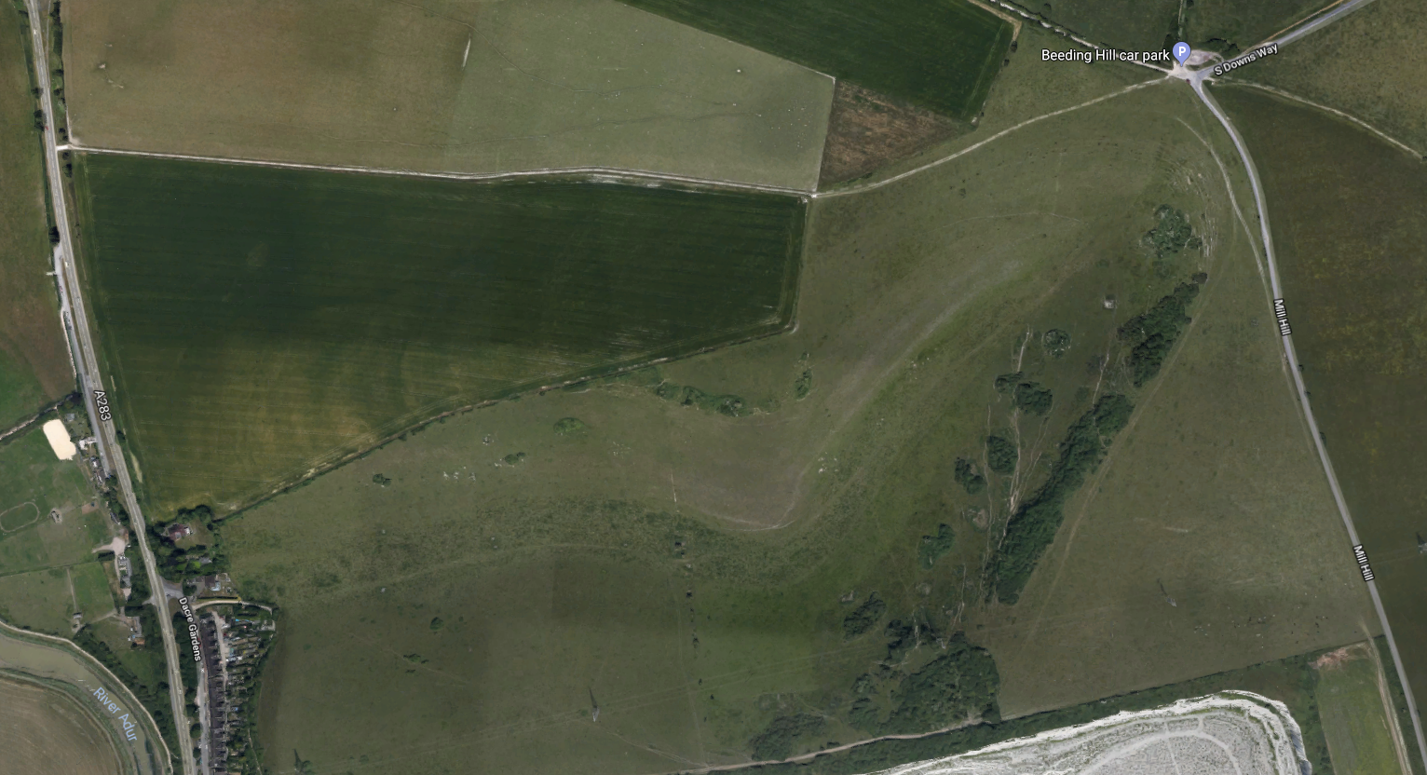
2TQ 18284 06248
4TQ 18284 06248
5TQ 18284 06248
3TQ 18284 06248
1TQ 18284 06248

UKBMS Instructions
These are the rather imprecise instructions on UKBMS. The grid references are 100m squares so not particularly helpful.
1 TQ205095 Near top of south-facing slope of deep valley 430m
2 TQ205094 Mid-height of south-facing valley slope 340m
3 TQ205093 North side near bottom of south-facing side of valley 340m
4 TQ200093 Bottom of south-facing side of valley, less well maintained and with longer sward than previous Sections. 700m

