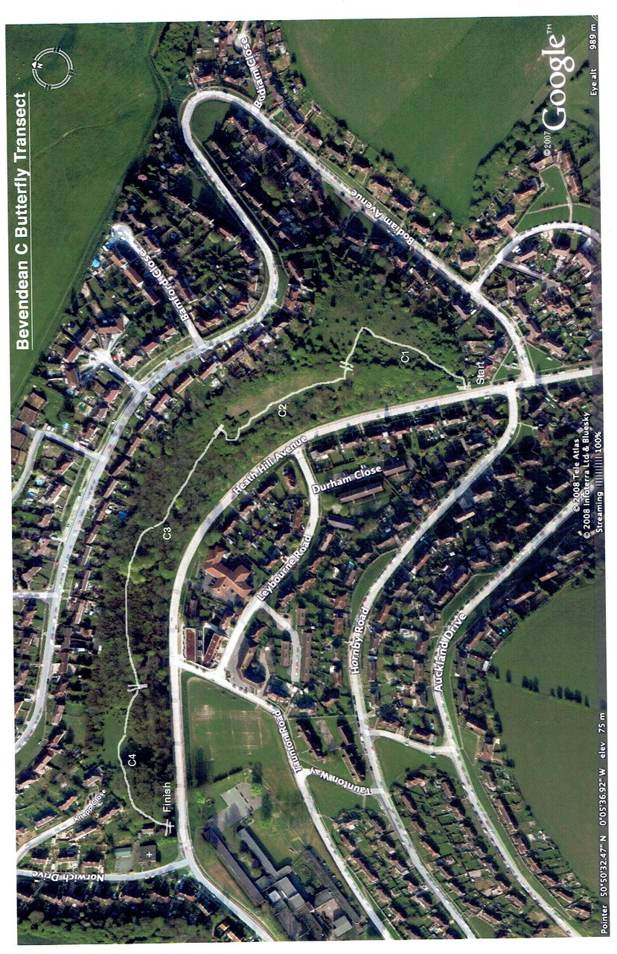

Section 1 | Start at gate
Section 2
Section 3
Section 4

