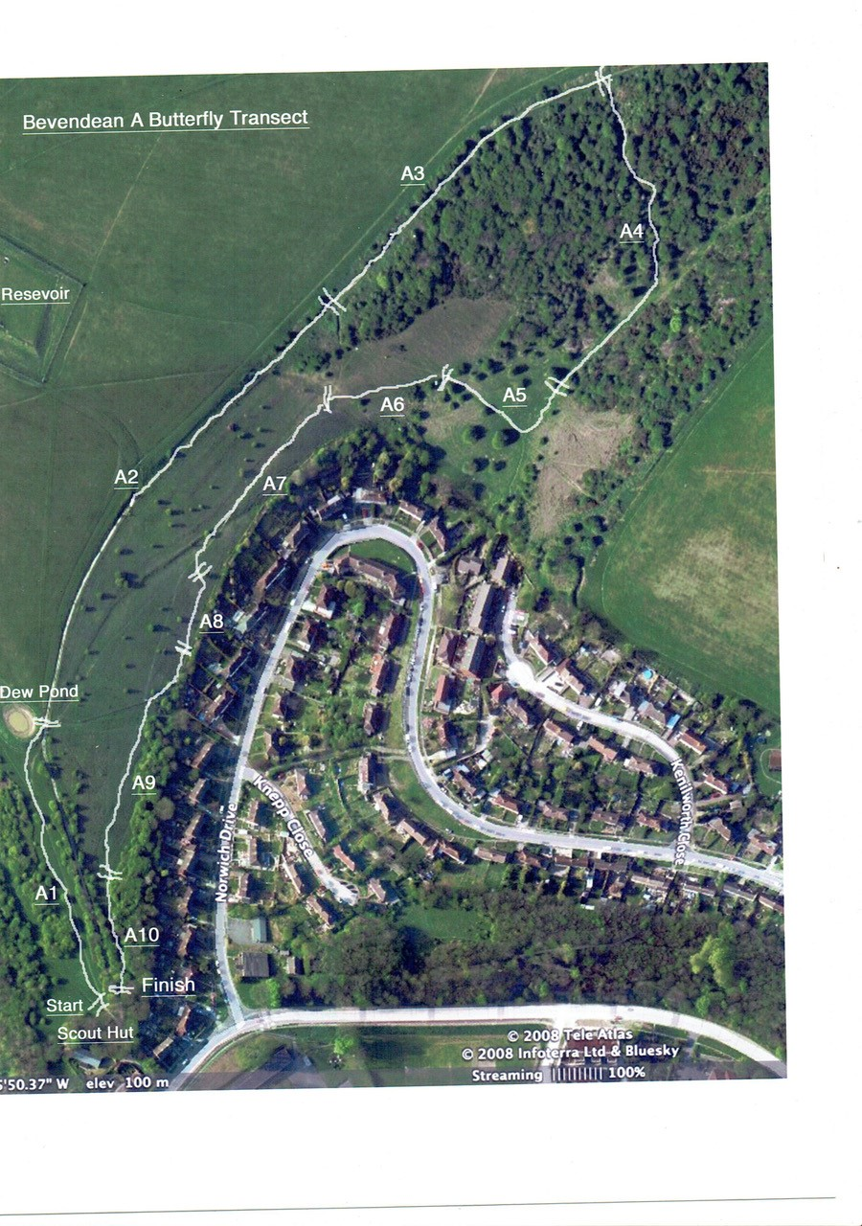

Section 1 | Start TQ 33825 06504 end at Dew pond TQ 33752 06685
Section 2 | TQ 33752 06685 to TQ 33894 06961 along the path
Section 3 | TQ 33894 06961 to TQ 34011 07100
Section 4 | TQ 34011 07100 through wooded area to TQ 34027 06948 where emerges
Section 5 | TQ 34027 06948 short dogleg via TQ 34017 06923 to TQ 33979 06941
Section 6 | TQ 33902 06918 To TQ 33902 06918 across the grass
Section 7 | TQ 33902 06918 to TQ 33850 06781
Section 8 | TQ 33850 06781 to TQ 33844 06749 (really short )
Section 9 | TQ 33844 06749 to where the wood starts TQ 33824 06602
Section 10 | TQ 33824 06602 to the gate at TQ 33825 06504

