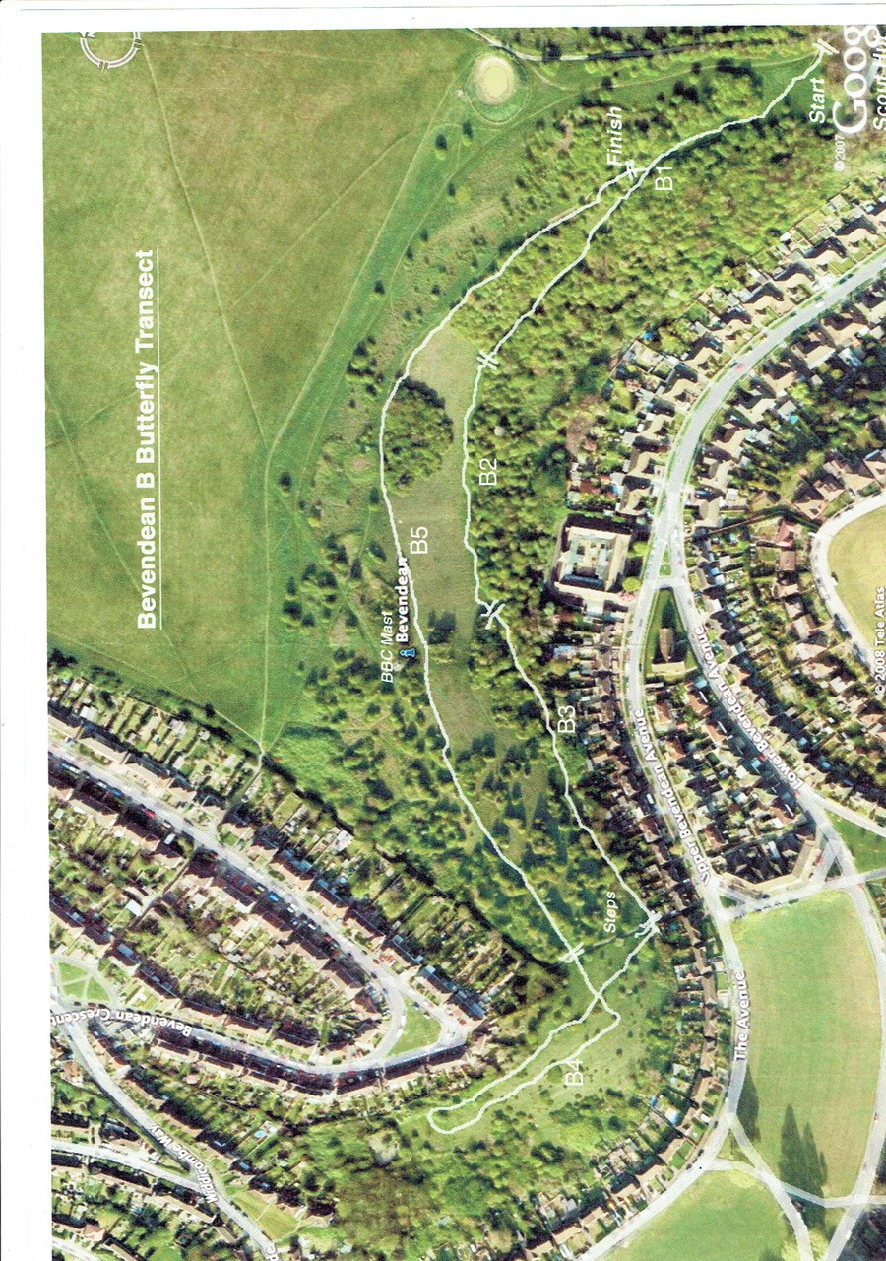

Section 1 | Start at gate TQ 33827 06504 up through the woods. Ends at the grass TQ 33594 06653
Section 2 | TQ 33594 06653 along the edge TQ 33464 06613
Section 3 | TQ 33464 06613 to the steps TQ 33299 06471
Section 4 | TQ 33299 06471 a loop up and back to the steps at the top TQ 33268 06513
Section 5 | TQ 33268 06513 follow the top of the hill round and then head back to the gate to end TQ 33827 06504

