LANCING RING A

1 | TQ 18284 06248 | Start at car park a take the most southern path to the east
2 | TQ 18181 06179 | Follow the hedge east – this is sheltered from the wind
3 | TQ 17877 06159 | South on path through scrub – not the path immediately against the hedge with buildings to the left
4 | TQ 17843 05999 | Turn right and head east through nettle patch, with nettles on either side of you
5 | TQ 17699 06029 | Head north east to the base of the woodes area
6 | TQ 17837 06153 | Head north and then bear east on the foot path through the woods to come out south of the dew pond
7 | TQ 18043 06460 | Take the path across the grass heading south east to the footpath
8 | TQ 18239 06349 | Head down the footpath to the chalk pit
9 | TQ 18543 06231 | Follow the obvious path west from the chalk pit. This should bring yoou out onto the road 20 metres before the car park where the transect ends.

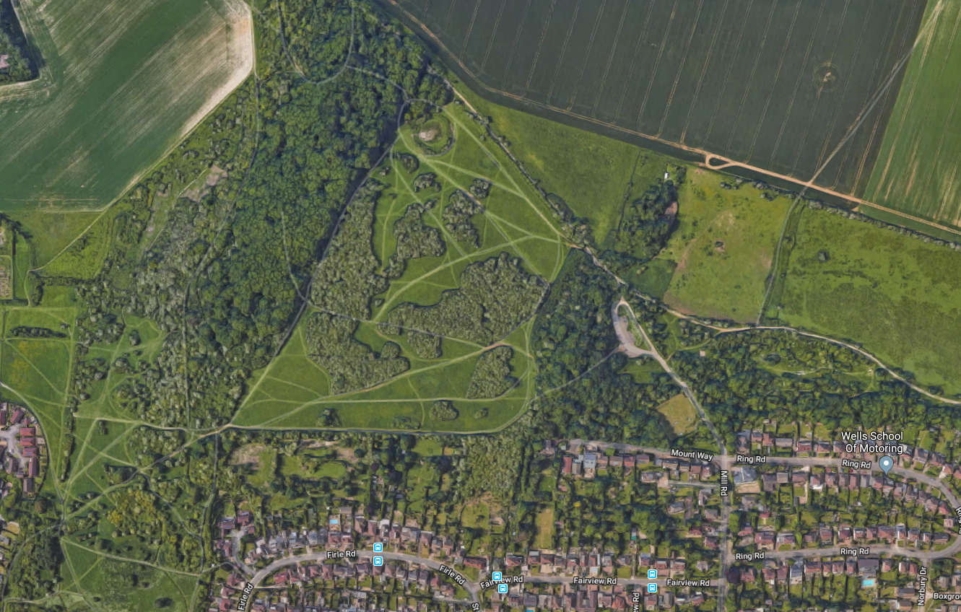
6TQ 18284 06248
5TQ 18284 06248
4TQ 18284 06248
9TQ 18284 06248
8TQ 18284 06248
7TQ 18284 06248
6TQ 18284 06248
3TQ 18284 06248
2TQ 18284 06248
1TQ 18284 06248

