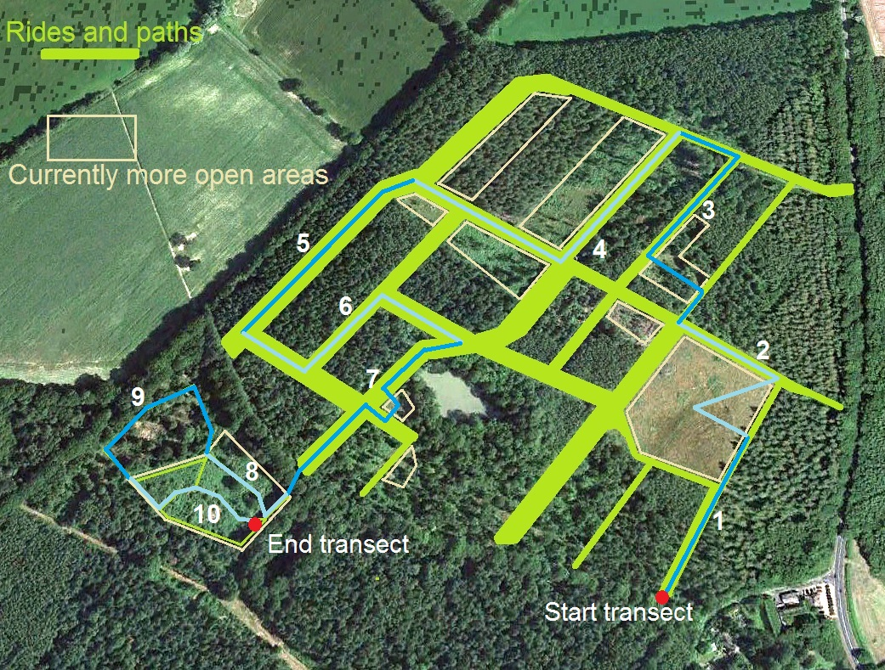

Section | Start | End | Notes
1 | TQ 51537 14722 | TQ 51629 14908 | Begins at gate. End at point where grass on left starts getting longer
2 | TQ 51629 14908 | TQ 51551 15013 | Out to TQ 51573 14933 and back to TQ 51649 14948 in the corner
3 | TQ 51551 15013 | TQ 51541 15212 | Down to TQ 51582 15059 then turn left to TQ 51524 15084 turn right to TQ 51591 15180  Then left to TQ 51541 15212
4 | TQ 51541 15212 | TQ 51269 15171 | Up ride to TQ 51437 15077 and turn right to TQ 51269 15171 and end
5 | TQ 51269 15171 | TQ 51119 14977 | All the way down to TQ 51119 14977
6 | TQ 51119 14977 | TQ 51311 14974 | Head to TQ 51173 14953 and turn left to TQ 51244 15036 and right to TQ 51311 14974
7 | TQ 51311 14974 | TQ 51174 14831 | Pond kink head south to end of Rowland Woode section on the parish boundary/footpath
8 | TQ 51174 14831 | TQ 51095 14866 | Head to shed and turn right. Go to Pete’s Bench TQ 51095 14866. Follow path past it to TQ 51070 14913
9 | TQ 51095 14866 | TQ 51019 14846 | Turn left to TQ 50997 14867 and head up to TQ 51019 14846
10 | TQ 51019 14846 | TQ 51154 14804 | Return to shed via path through middle of heath TQ 51095 14826

